滅蟲服務
檔案編號：THG2/N211/23

敬啟者：

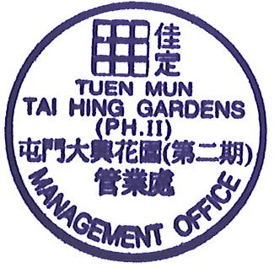
本屋苑將於二零二三年四月二十四日(星期一)進行定期滅蟲服務，屆時滅蟲承辦商將會在花園及大廈各樓層內之公眾地方，噴射殺蟲藥物及放置老鼠藥。敬希各業戶留意及看管家中小孩，切勿接觸該等藥物而發生危險。
如有任何查詢，請致電2465 2233與管業處職員聯絡。

此致
大興花園第二期各業戶
大興花園第二期管業處 謹啟
二零二三年四月二十一日

To: All Owners/Occupiers of Tai Hing Gardens Phase II
Pest Control Service
The pest control service contractor will carry out the routine service on 24th April 2023 (Monday) in common area of each floor of Towers and the planters.

Please be informed that diffusion of bad smell would be occurred during this period. We would like to have your attention for this arrangement and prevention of the children to touch the pesticide from those service areas.

If you have any queries, please feel free to contact management office at 2465 2233.

Thank you for your attention.

Guardian Property Management Limited

Management Office of

Tai Hing Gardens Phase II
此通告張貼至2023年4月24日

